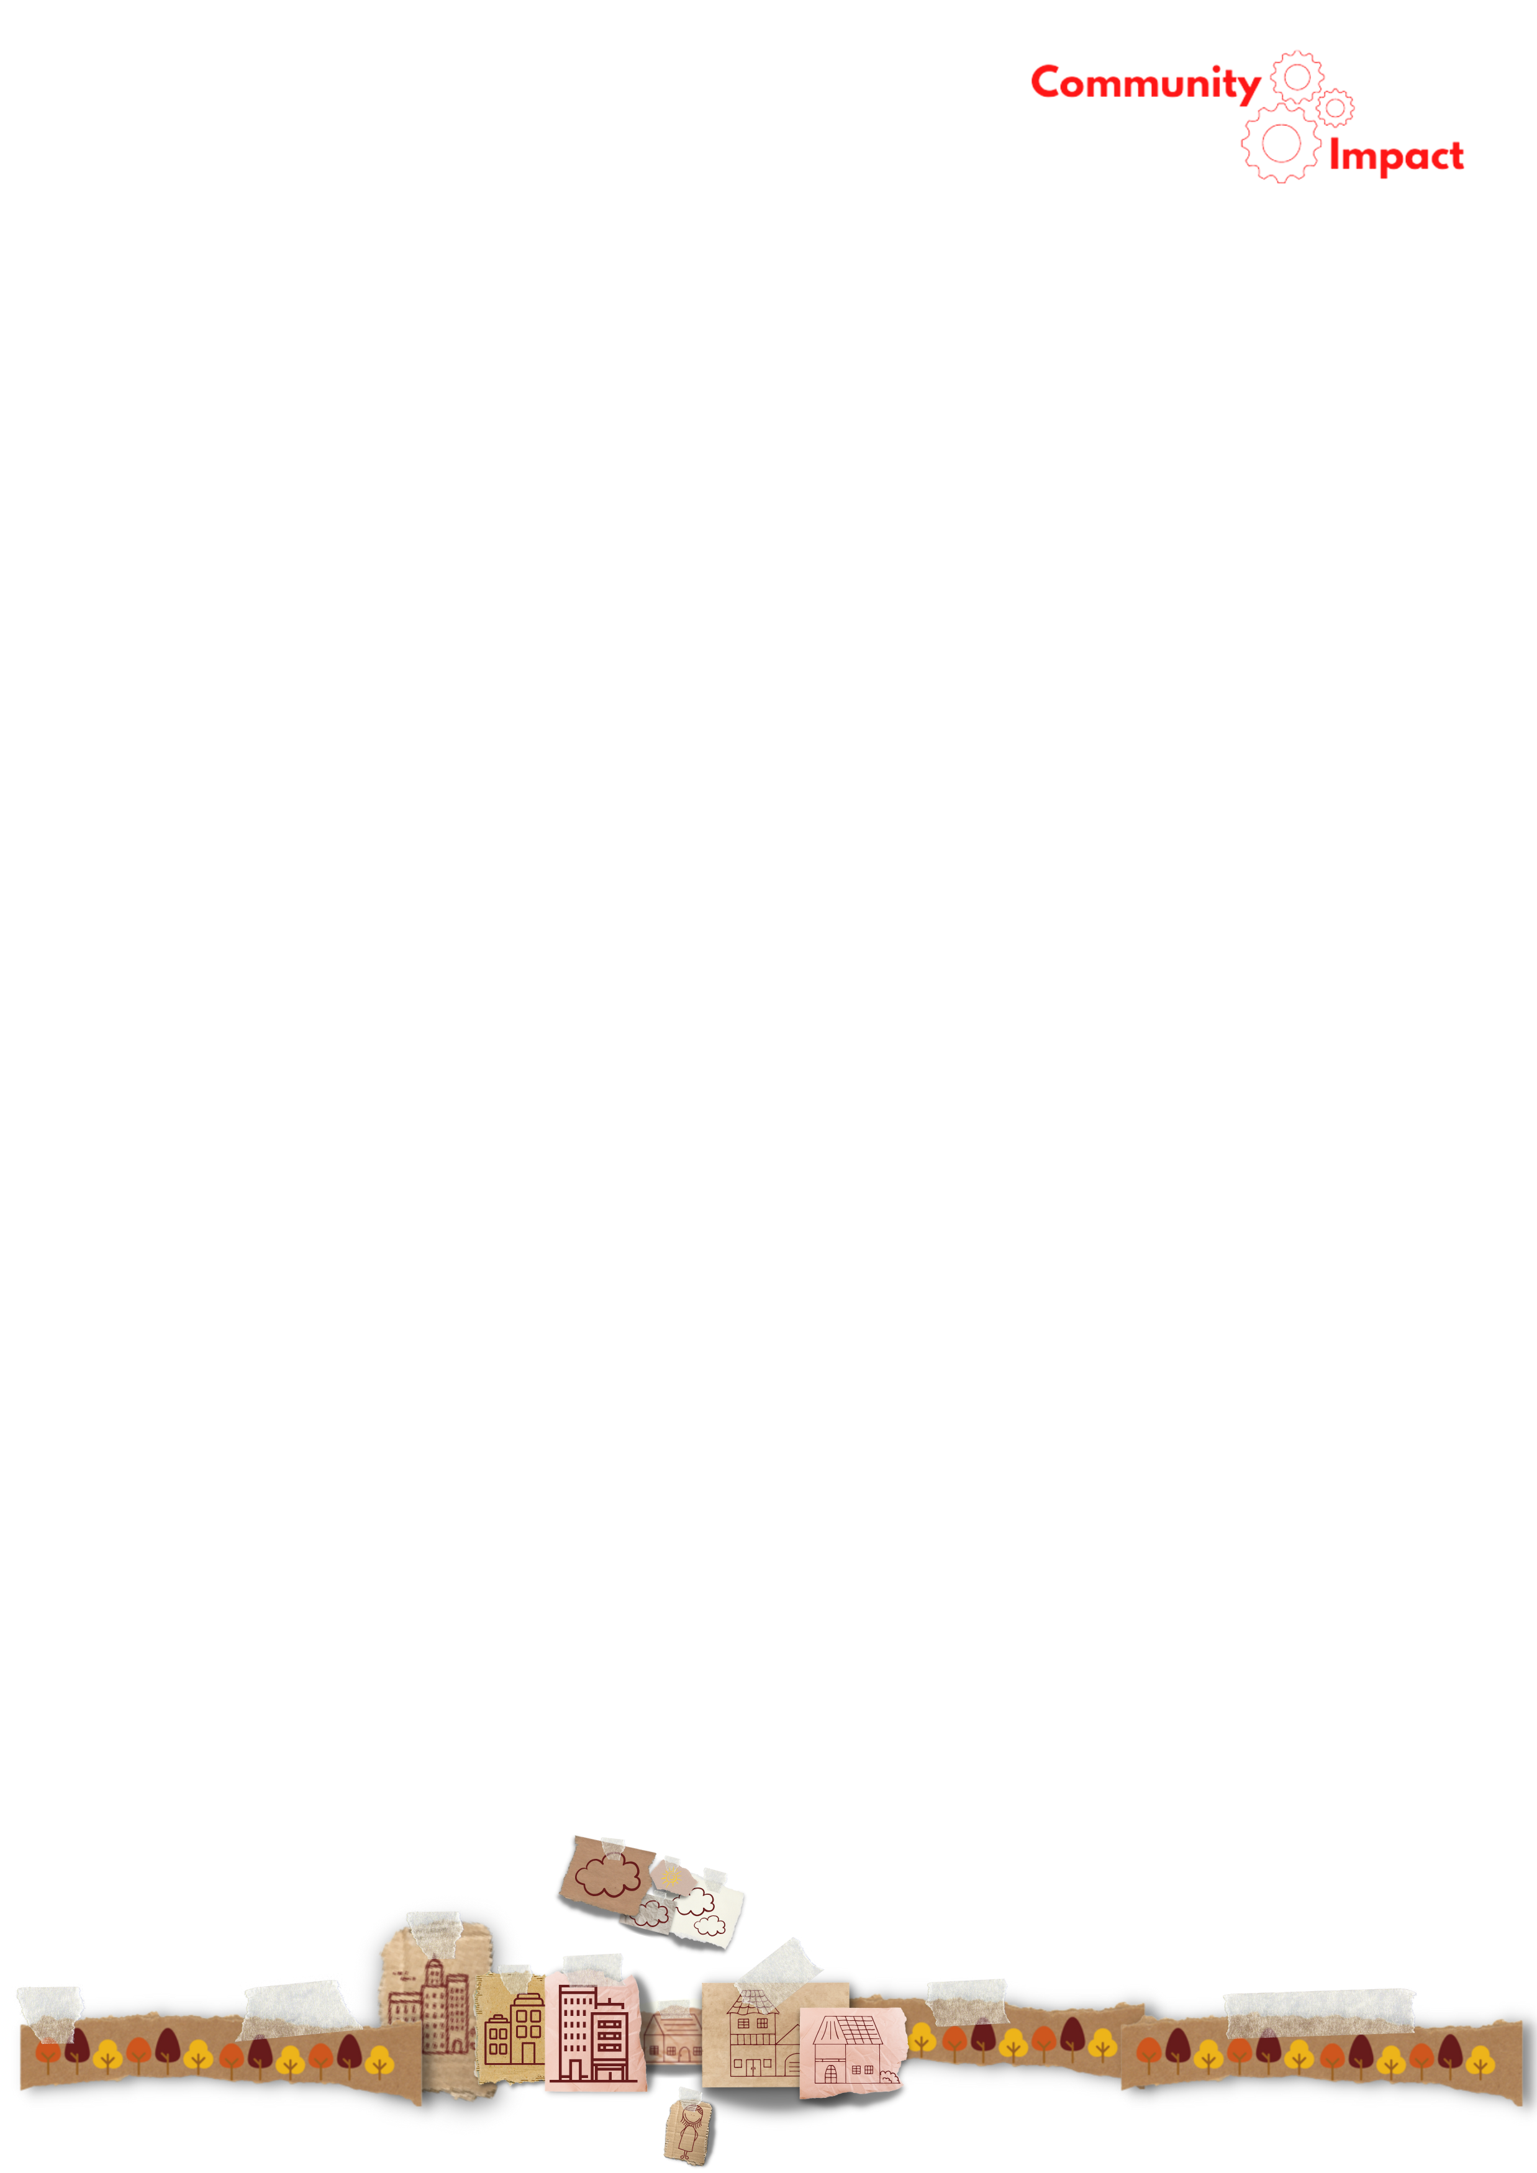

Measuring Impact Across a Complex Residential Service Offer

A [name of service/programme] evaluation strategy

- About YMCA

YMCA is one of the largest voluntary sector providers of services for young people in the UK, with around 70 independent local YMCAs operating under a shared commitment to youth development and community support. The YMCA offer is wide-ranging and includes both residential and off-site services, spanning supported housing, youth work, mental health and wellbeing services, employability programmes, advice and advocacy, and targeted support for groups such as young carers, care leavers, and those at risk of homelessness. Many YMCAs also deliver family services, run food and welfare support schemes, and provide access to community spaces and affordable venues.

  - The Evaluation ‘Challenge’

This diversity of provision presents a challenge for measuring the impact of such a complex offer, and evaluation must be designed to reflect the scale and complexity of the offer. As a whole, the YMCA movement represents a complex intervention, delivering multiple, interacting services that vary significantly in their delivery models and client pathways. These services are highly heterogeneous, especially in how young people engage with them. There is wide variation in the length of exposure (how long a young person engages), intensity (the quality and depth of the engagement), and dose (the number of engagements or sessions), as well as in setting, with services delivered in residential, outreach, or community-based environments. A meaningful evaluation strategy must take account of these variations, ensuring that data collection is appropriate, proportionate, and focused on evidencing change. Table 1, below summarises a typical YMCA offer based on an audit of 84 YMCAs in England.

Table 1 - YMCA Service Themes

Strand | Services and programmes
Strand 1: Ongoing Support | Accommodation & Housing Support  Intensive Mental Health Support
Strand 2: Fixed-Term Programmes | Mentoring, Wellbeing Groups, Training & Employment, Disability-Focused Support, Young Carers
Strand 3: Short-Term / Episodic | Advice & Advocacy, Food & Welfare Support

- What We Will Do

The evaluation approach is intended to bring clarity and structure to what is, by design, a broad and diverse service offer. YMCA services are delivered in a wide variety of settings, with differing levels of intensity and duration of engagement. Rather than evaluating each service in isolation, the model adopted here groups services according to the type of journey a young person takes through the organisation.

To support this, all YMCA services and programmes are brought into a single, organisation-wide evaluation process by assigning them to one of three strands. Each strand corresponds to a different type of service journey, based on the young person’s level of contact with the YMCA and the duration of their engagement. This approach allows us to reflect the diversity of the YMCA offer while reducing duplication and avoiding over-surveying of individuals who access multiple services.

- Strand 1 includes young people receiving sustained support through residential accommodation and wrap around support (Accommodation & Wraparound Support, Independent Living Support).
- Strand 2 covers fixed-term programmes such as training, mentoring, or structured wellbeing interventions (Youth Services, Health & Wellbeing, Training & Education, Family & Community Services, Specialist Support Services).
- Strand 3 applies to short-term or episodic support, such as outreach, advice, advocacy, or drop-in services (Advice & Advocacy, Food & Welfare Support, Venue Hire & Community Space).

Each strand will have its own evaluation design, tailored to the nature of the engagement and the type of service. This will ensure a proportionate, consistent, and meaningful approach to measuring impact across the full range of YMCA provision.

  - Methodology

The evaluation methodology reflects the structure of the strand model, with each strand applying a consistent, proportionate approach to data collection. All strands will include a qualitative element alongside core outcome measurement.

- Strand 1: Evaluation will include two survey points—one at referral (baseline assessment) and one either at 9 months or at the point of exit, whichever comes first. In addition, insight will be gathered through group-based qualitative methods such as focus groups or user-led seminars.

- Strand 2: Evaluation will consist of a survey at the start of the programme and a follow-up survey on completion. Qualitative insight will be gathered through interviews with a sample of participants.

- Strand 3: Evaluation will draw on structured case reviews based on anonymised and aggregated client case notes. This will be combined with a small sample of client interviews to explore individual experience and perceived impact. This mixed approach is suitable for short-term or episodic services such as advice, advocacy, and food or welfare support, and will be reported using a case study and composite example format.

Each approach is designed to align with the expected level of engagement, journey length, and service setting. Standardised surveys are already in place for use with both Strand 1 and Strand 2 services:

Strand 1: Residential Support Survey – designed for young people living in supported accommodation or receiving intensive wraparound support.

Strand 2 Surveys, tailored to each of the following service areas:

- Youth Services Survey (covers: youth clubs, mentoring, outreach, informal education, creative and sporting activities)
- Health & Wellbeing Survey (covers: counselling, mental health drop-ins, fitness and wellbeing programmes, self-esteem support)
- Training & Education Survey (covers: employability programmes, NEET support, accredited learning, vocational training)
- Family & Community Services Survey (covers: parenting support, young carers services, family work, intergenerational projects)
- Specialist Support Services Survey (covers: support for care leavers, young offenders, young people with disabilities or complex needs)

Each survey links directly to outcome indicators relevant to its service area and supports consistent, comparable data collection across participating YMCAs. Within Strand 2, services with dedicated surveys include: mentoring programmes, wellbeing sessions, training and employability courses, parenting support, support for young carers, support for care leavers, and provision for young people with disabilities. Other services in Strand 2 will use a general fixed-programme survey unless otherwise specified.

- Actions

This section outlines the process for embedding the evaluation strategy into local YMCA delivery. While the overarching model is shared, individual YMCAs will each develop a local implementation plan that reflects their specific service mix, delivery settings, and operational capacity.

- Stage 1: Service Audit – The first step is to understand what is being delivered and to whom. Each YMCA will undertake a local audit to map its services against the strand model, identify the relevant service themes, and clarify the client groups served within each. This audit provides the foundation for selecting appropriate evaluation tools and understanding the diversity of journeys experienced by young people.

- Stage 2: Outcomes and Indicators – This stage also involves matching service-specific outcomes and indicators to the relevant strands. Each YMCA will identify which numbered outcomes (e.g. A: Financial Security, B: Access to Rights, etc.) and indicators (e.g. A2, B5, F1) apply to their services, ensuring that evaluation is outcome-led and grounded in the intended changes for each programme. Once services have been mapped, the next step is to identify which outcomes and indicators apply to each strand and service theme. This ensures that evaluation activities are focused on the kinds of change that are realistic, measurable, and meaningful within the context of each programme or intervention.

- Stage 3: Evaluation Design – With the outcomes and indicators defined, the next step is to determine the appropriate evaluation design for each strand. This includes selecting which of the pre-designed evaluation tools (such as standardised surveys and interview templates) are best suited to each service or setting. This includes deciding on the right tools, timing of data collection, and any adaptations needed for specific delivery models. The evaluation design must balance methodological rigour with feasibility and ensure that both qualitative and quantitative evidence is built into the process.

- Stage 4: Sampling – Each YMCA will determine how to select a representative sample of young people for participation in qualitative and, where appropriate, survey-based evaluation. Sampling must reflect the diversity of service types, client backgrounds, and levels of engagement to ensure that findings are inclusive and credible.

- Stage 5: Data Collection – Each YMCA will collect data in line with the design appropriate to the strand their services fall under. Strand 1 will involve baseline and follow-up surveys along with focus group-style insight sessions; Strand 2 will include entry and exit surveys with qualitative interviews; and Strand 3 will use structured case reviews supported by sample interviews. All data collection will follow agreed timepoints and protocols to ensure consistency across the network.

- Stage 6: Analysis – Each YMCA will analyse its data in a way that reflects the outcomes and service themes relevant to its work. Standard Excel-based analysis templates have been supplied as part of this toolkit for each of the strand-specific surveys to support consistent data handling and reporting across the network. These will include automated calculations of outcome achievement and basic comparison metrics.

- Stage 7: Reporting – Each YMCA will report its evaluation findings using a standard reporting template supplied as part of this toolkit. This ensures consistency in how results are communicated across different services and settings, while allowing space for local insight and reflection. Templates will include space for outcome data, qualitative insight, and case examples where relevant.

- Stage 8: Business Development – The final stage is to use evaluation data in a way that supports strategic growth and sustainability. YMCA services should be able to apply their data to strengthen funding bids, support commissioning conversations, and demonstrate impact to stakeholders. Executive teams and boards should also use evaluation outputs to inform planning and oversight. To support this, dashboard templates and summary formats have been included in the toolkit, helping each YMCA move from data collection to purposeful use.

4. Timeline
Stage | Title | W/C 1 | W/C2 | W/C 3 | W/C 4 | W/C 5 | W/C 6 | W/C 7
1 | Service Audit
2 | Outcomes and Indicators
3 | Evaluation Design
4 | Sampling
5 | Data Collection
6 | Analysis
7 | Reporting
8 | Business Development

